John Kaminski

Dr. Abhishek Dutta

ECE 3111

19 April 2019

**ECE 3111 Term Project**

1. **Introduction**

This project covers the physical modeling and control of a quadcopter aircraft. The first task is to determine the linear approximation that represents the nonlinear physics equations that describe the motion of the quadcopter about a given operating point. This approximation then must be converted into a state space model: $\dot{x}=Ax+Bu$, and $y=Cx$. The next task is to compute the transfer function from the state space model, and create the block diagram. Then the goal is to design a PID controller that can hover the quadcopter at a set height with a given settling time.

1. **Procedure**
2. *Linearization*
   1. The Following equations were to be linearized around the equilibrium point:

$x=y=z=ϕ=θ=ψ=0$, where ϕ, θ, and ψ denote roll, pitch, and yaw.



$\dot{x}=v_{x}$

$\dot{y}=v_{y}$

$\dot{z}=v_{z}$

$\dot{v_{x}}=-\frac{k_{d}}{m}v_{x}+\frac{{kc}_{m}}{m}(sinψsinϕ+cosψcosϕsinθ)(v_{1}^{2}+v_{2}^{2}+v_{3}^{2}+v_{4}^{2})$

$\dot{v_{y}}=-\frac{k_{d}}{m}v_{y}+\frac{{kc}_{m}}{m}(cosϕsinψsinθ-cosψsinϕ)(v_{1}^{2}+v_{2}^{2}+v_{3}^{2}+v_{4}^{2})$

$\dot{v_{z}}=-\frac{k_{d}}{m}v_{z}-g+\frac{{kc}_{m}}{m}(cosϕcosθ)(v_{1}^{2}+v_{2}^{2}+v_{3}^{2}+v_{4}^{2})$

$\dot{ϕ}=ω_{x}+ω_{y}\left(sinϕtanθ\right)+ω_{z}(cosϕtanθ)$

$\dot{θ}=ω_{y}\left(cosϕ\right)+ω_{z}(-sinθ)$

$\dot{ψ}=ω_{y}\left(\frac{sinϕ}{cosθ}\right)+ω_{z}\left(\frac{cosϕ}{cosθ}\right)$

$\dot{ω_{x}}=\frac{Lkc_{m}}{I_{xx}}\left(v_{1}^{2}-v_{3}^{2}\right)-(\frac{I_{yy}-I_{zz}}{I_{xx}})ω_{y}ω_{z}$

$\dot{ω_{y}}=\frac{Lkc_{m}}{I_{yy}}\left(v_{2}^{2}-v_{4}^{2}\right)-(\frac{I_{zz}-I_{xx}}{I_{yy}})ω_{x}ω_{z}$

$\dot{ω_{z}}=\frac{Lkc_{m}}{I_{zz}}\left(v_{1}^{2}-v_{2}^{2}+v_{3}^{2}-v_{4}^{2}\right)-\left(\frac{I_{xx}-I_{yy}}{I_{zz}}\right)ω_{x}ω_{y}$

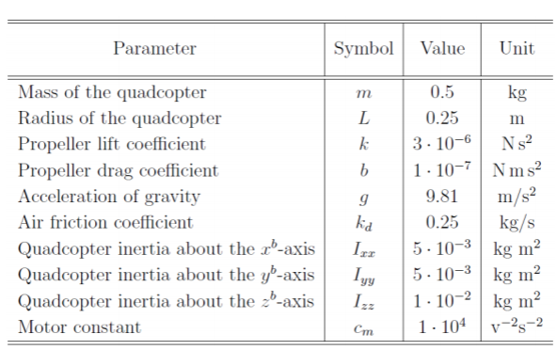 The following constants were given for these equations:

For the system of the quadcopter:

* 1. During linearization, to keep the system linear, when the term

$\frac{kc_{m}}{m}(v_{1}^{2}+v_{2}^{2}+v_{3}^{2}+v_{4}^{2})$, is multiplied by another state vector variable, it is reduced to $g$, because all of the thrust forces from the quadcopter must equal $mg$ for the equilibrium point. Additionally, the values $v_{1}^{2}, v_{2}^{2}, v_{3}^{2}, v_{4}^{2}$ will be written as $u_{1}, u_{2}, u_{3}, u_{4}$, since those values are the inputs. To obtain the linearized equations, the following method was used for each equation, where $(eq)$ corresponds to the equilibrium point: $\left(x,y,z,ϕ,θ,ψ\right)=(0,0,0,0,0,0)$:

$$f_{i}\left(x,y,z,ϕ,θ,ψ\right)=f_{i}\left(eq\right)+\frac{δf_{i}}{δx}\left(eq\right)x+\frac{δf_{i}}{δy}\left(eq\right)y+\frac{δf_{i}}{δz}\left(eq\right)z+\frac{δf_{i}}{δϕ}\left(eq\right)ϕ+\frac{δf_{i}}{δθ}\left(eq\right)θ+\frac{δf_{i}}{δψ}\left(eq\right)ψ+\frac{δf_{i}}{δu_{1}}\left(eq\right)u_{1}+\frac{δf_{i}}{δu_{2}}\left(eq\right)u_{2}+\frac{δf_{i}}{δu_{3}}\left(eq\right)u_{3}+\frac{δf_{i}}{δu_{4}}\left(eq\right)u_{4}$$

The linearized equations are written below. It should be noted that equations 1-3 were already linear, and equations 7-9 were simply linearized by their definitions, meaning that the derivative of the roll angle is simply the angular velocity about the x-axis, and so on for the pitch and yaw angles. In addition, at the equilibrium point, all velocities and accelerations equate to zero.

$\dot{x}=v_{x}$

$\dot{y}=v_{y}$

$\dot{z}=v_{z}$

$\dot{v_{x}}=\frac{-k_{d}}{m}v_{x}+gθ$

$\dot{v_{y}}=\frac{-k_{d}}{m}v_{y}-gϕ$

$\dot{v_{z}}=\frac{-k_{d}}{m}+\frac{{kc}_{m}}{m}(u_{1}+u_{2}+u_{3}+u_{4})$

$\dot{ϕ}=ω_{x}$

$\dot{θ}=ω_{y}$

$\dot{ψ}=ω_{z}$

$\dot{ω_{x}}=\frac{Lkc_{m}}{I_{xx}}(u_{1}-u_{3})$

$\dot{ω_{y}}=\frac{Lkc_{m}}{I_{yy}}(u_{2}-u_{4})$

$\dot{ω_{z}}=\frac{Lkc_{m}}{I_{zz}}\left({u_{1}-u}_{2}+u_{3}-u_{4}\right)$

1. *System Modeling*

The linearized equations were to be put into state space form as follows:

$$\dot{x}=Ax+Bu$$

$$y=Cx$$

Where *A* is a 12x12 sized matrix, *B* is a 12x4 sized matrix, and *C* isa 6x12 sized matrix. The values in the matrix *A* are each defined as $A_{ij}=\frac{{δf}_{i}}{δx_{j}}(eq)$, and the values in the matrix *B* are each defined as $B_{ik}=\frac{{δf}_{i}}{δu_{k}}(eq)$. From the above equations, the state space can be written as:

$$\left[\begin{matrix}\dot{x} \\ \dot{y} \\ \dot{z} \\ \dot{v_{x}} \\ \dot{v_{y}} \\ \dot{v_{z}} \\ \dot{ϕ} \\ \dot{θ} \\ \dot{ψ} \\ \dot{ω_{x}} \\ \dot{ω_{y}} \\ \dot{ω_{z}}\end{matrix}\right]=\left[\begin{matrix}0 & 0 & 0 & 1 & 0 & 0 & 0 & 0 & 0 & 0 & 0 & 0 \\ 0 & 0 & 0 & 0 & 1 & 0 & 0 & 0 & 0 & 0 & 0 & 0 \\ 0 & 0 & 0 & 0 & 0 & 1 & 0 & 0 & 0 & 0 & 0 & 0 \\ 0 & 0 & 0 & \frac{{-k}_{d}}{m} & 0 & 0 & 0 & g & 0 & 0 & 0 & 0 \\ 0 & 0 & 0 & 0 & \frac{{-k}_{d}}{m} & 0 & -g & 0 & 0 & 0 & 0 & 0 \\ 0 & 0 & 0 & 0 & 0 & \frac{{-k}_{d}}{m} & 0 & 0 & 0 & 0 & 0 & 0 \\ 0 & 0 & 0 & 0 & 0 & 0 & 0 & 0 & 0 & 1 & 0 & 0 \\ 0 & 0 & 0 & 0 & 0 & 0 & 0 & 0 & 0 & 0 & 1 & 0 \\ 0 & 0 & 0 & 0 & 0 & 0 & 0 & 0 & 0 & 0 & 0 & 1 \\ 0 & 0 & 0 & 0 & 0 & 0 & 0 & 0 & 0 & 0 & 0 & 0 \\ 0 & 0 & 0 & 0 & 0 & 0 & 0 & 0 & 0 & 0 & 0 & 0 \\ 0 & 0 & 0 & 0 & 0 & 0 & 0 & 0 & 0 & 0 & 0 & 0\end{matrix}\right]⋅\left[\begin{matrix}x \\ y \\ z \\ v_{x} \\ v_{y} \\ v_{z} \\ ϕ \\ θ \\ ψ \\ ω_{x} \\ ω_{y} \\ ω_{z}\end{matrix}\right]+\left[\begin{matrix}0 & 0 & 0 & 0 \\ 0 & 0 & 0 & 0 \\ 0 & 0 & 0 & 0 \\ 0 & 0 & 0 & 0 \\ 0 & 0 & 0 & 0 \\ \frac{{kc}_{m}}{m} & \frac{{kc}_{m}}{m} & \frac{{kc}_{m}}{m} & \frac{{kc}_{m}}{m} \\ 0 & 0 & 0 & 0 \\ 0 & 0 & 0 & 0 \\ 0 & 0 & 0 & 0 \\ \frac{Lkc_{m}}{I_{xx}} & 0 & \frac{-Lkc_{m}}{I_{xx}} & 0 \\ 0 & \frac{Lkc_{m}}{I_{yy}} & 0 & \frac{-Lkc_{m}}{I_{yy}} \\ \frac{Lkc_{m}}{I_{zz}} & \frac{-Lkc_{m}}{I_{zz}} & \frac{Lkc_{m}}{I_{zz}} & \frac{-Lkc_{m}}{I_{zz}}\end{matrix}\right]⋅\left[\begin{matrix}u_{1} \\ u_{2} \\ u_{3} \\ u_{4}\end{matrix}\right]$$

$${\left[\dot{x}\right]}_{12x1}={\left[A\right]}_{12x12}⋅{\left[x\right]}_{12x1}+{\left[B\right]}_{12x4}⋅{\left[u\right]}_{4x1}$$

$$\left[\begin{matrix}x \\ y \\ z \\ ϕ \\ θ \\ ψ\end{matrix}\right]=\left[\begin{matrix}1 & 0 & 0 & 0 & 0 & 0 & 0 & 0 & 0 & 0 & 0 & 0 \\ 0 & 1 & 0 & 0 & 0 & 0 & 0 & 0 & 0 & 0 & 0 & 0 \\ 0 & 0 & 1 & 0 & 0 & 0 & 0 & 0 & 0 & 0 & 0 & 0 \\ 0 & 0 & 0 & 0 & 0 & 0 & 1 & 0 & 0 & 0 & 0 & 0 \\ 0 & 0 & 0 & 0 & 0 & 0 & 0 & 1 & 0 & 0 & 0 & 0 \\ 0 & 0 & 0 & 0 & 0 & 0 & 0 & 0 & 1 & 0 & 0 & 0\end{matrix}\right]⋅\left[\begin{matrix}x \\ y \\ z \\ v_{x} \\ v_{y} \\ v_{z} \\ ϕ \\ θ \\ ψ \\ ω_{x} \\ ω_{y} \\ ω_{z}\end{matrix}\right]$$

$${\left[y\right]}_{6x1}={\left[C\right]}_{6x12}⋅{\left[x\right]}_{12x1}$$

1. *PID Control Design and Analysis*
   1. When computing the transfer function, it should be noted that since the only requirement of this quadcopter is to achieve a height of 5 feet, only the inputs related to *z* should be considered. In addition, because the quadcopter should come up in a straight path, all of the angles should remain zero, meaning that all the voltage inputs should equal each other. Therefore, $u_{1}+u_{2}+u_{3}+u_{4}$ can be simply reduced to $u$. From the state space representation, the transfer function can be computed from the following steps:
      1. $\dot{v_{z}}=\frac{{-k}_{d}}{m}v_{z}+\frac{{kc}_{m}}{m}u$ (From state space)
      2. $y=z$ (The only measured output will be z)
      3. $S^{2}Z=-S\frac{k_{d}}{m}Z+\frac{{kc}_{m}}{m}U$ (Take the Laplace Transform of $\dot{v_{z}}$)
      4. $Z= \frac{\frac{kc_{m}}{m}}{S^{2}+S\frac{k_{d}}{m}}U$ (Solve for Z)
      5. $Y=Z$ (Take the Laplace Transform of $y$)
      6. $Y= \frac{\frac{kc_{m}}{m}}{S^{2}+S\frac{k_{d}}{m}}U$ (Plug in the value for Z)
      7. $\frac{Y}{U}=$ $\frac{\frac{kc_{m}}{m}}{S^{2}+S\frac{k_{d}}{m}}=\frac{0.06}{S^{2}+0.5S}$ (Solve for the Transfer Function and plug in values)
   2. Now that the transfer function from the control input to the output is known, the block diagram can be represented by:

*U*

*Y*

**∑**

$$0.06$$

$$\frac{1}{S}$$

$$\frac{1}{S}$$

*Y*

*Z- Position sensor*

*Plant Gp*

*Controller*

*R*

*d*

*e*

* 1. *Root Locus Plot*
     1. The Root Locus plot for the transfer function is shown below. It should be noted that the desired settling time of the system is 10s, meaning that

$σ=\frac{3}{10}.$ It can be seen that the second pole will never be in the plot range that corresponds to the given settling time, meaning that a controller is needed to get the desired settling time.

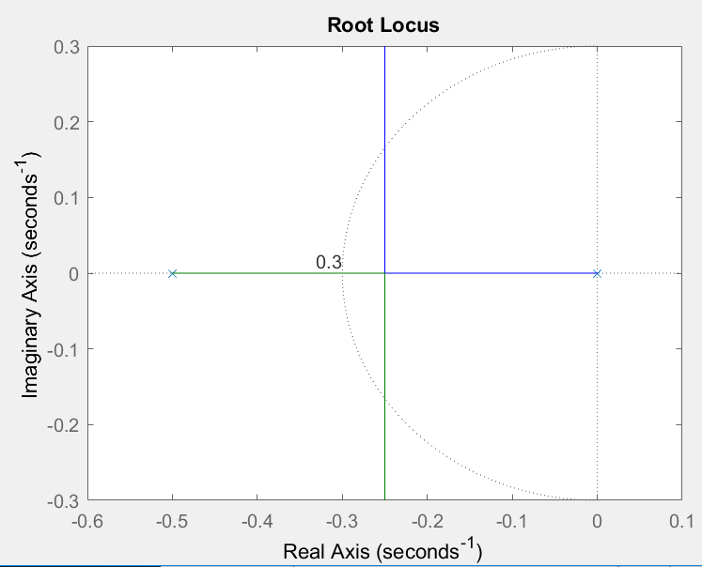

* + 1. A P controller will able to stabilize the system, as long as the gain for that controller is greater than zero. However, it will not be able to reach the given specifications, because the root locus shows that there is no value K that can be multiplied by the system that will put the pole corresponding to the blue line in the permissible region for poles.
    2. A PID controller will be able to stabilize the system and meet the required specifications, because it can be used to convert the system to a first order system, which can then meet the desired specification for the settling time. This is because a first order system will only have one pole, which will eliminate the effort to bring the rightmost pole on the root locus into the permissible region.
  1. *Bode Plot*

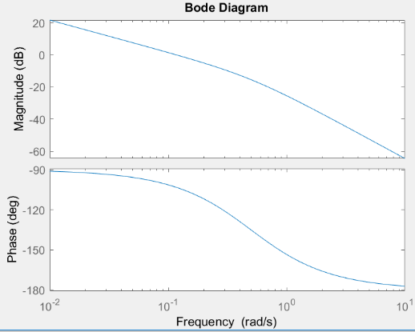The bode plot for the system is shown below:

It can be seen by analyzing this bode plot that the gain margin is infinite, because the phase of the system never hits $-{180}^{°}$, and the phase margin is about ${77}^{°}$, because at 0.117 rad/s, the magnitude is 0dB (1), and the phase is .

* 1. *PID Controller Design*

A PID controller is written as $k_{p}+sk_{d}+\frac{k_{i}}{s}$, or better equated as

$\frac{k_{d}}{s}\left(s^{2}+s\frac{k_{p}}{k_{d}}+\frac{k_{i}}{k_{d}}\right)$. To design the controller, the following steps were taken:

$G_{CL}=\frac{G_{c}G_{p}}{1+G_{c}G_{p}}$ (Write the equation for the closed loop system)

$G_{CL}=\frac{\frac{k_{d}}{s}\left(s^{2}+s\frac{k_{p}}{k_{d}}+\frac{k_{i}}{k_{d}}\right)\left(\frac{0.06}{s^{2}+0.5s}\right)}{1+\frac{k_{d}}{s}\left(s^{2}+s\frac{k_{p}}{k_{d}}+\frac{k_{i}}{k_{d}}\right)\left(\frac{0.06}{s^{2}+0.5s}\right)}$ (Plug in values from the block diagram)

$G_{CL}=\frac{0.06k_{d}\left(s^{2}+s\frac{k_{p}}{k_{d}}+\frac{k_{i}}{k_{d}}\right)}{s\left(s^{2}+0.5s\right)+0.06k_{d}\left(s^{2}+s\frac{k_{p}}{k_{d}}+\frac{k_{i}}{k_{d}}\right)}$ (Simplify the closed loop equation)

Note that the system can be transformed into a first order system if

$k_{i}≪1$ (very small and close to 0) and $\frac{k_{p}}{k_{d}}=0.5$.

$G_{CL}=\frac{0.06k_{d}}{s+0.06k_{d}} →\frac{1}{τs+1}, τ=\frac{1}{0.06k_{d}}$ (Set $k_{i}=0$ and $\frac{k_{p}}{k_{d}}=0.5$ to create a first order system and then solve for the time constant)

In a first order system the settling time is defined as $t_{s}=3τ$

$3τ<10seconds$ (Solve for the time constant for the given settling time)

$\frac{3}{0.06k_{d}}<10 →k_{d}>5$, $k_{p}>2.5$, $k_{i}≪1$ (Solve for $k_{d}$, $k_{p}$, and $k_{i}$)

Now the system needs to be verified to be stable, and the steady state error must be checked with a step reference at 5 feet.

Using Routh’s Criterion for stability, it can be seen that $k_{d}>0$ for the sytem to be stable, which is true from the proposed controller.

Next, the steady state error must be calculated with a step input of 5 feet. This is done by solving the transfer function from the reference to the error from the block diagram, and then taking the limit of the error as time goes to infinity.

$\frac{e}{r}=\frac{1}{1+G_{c}G_{p}}$ (Solve for the transfer function)

$\frac{e}{r}=\frac{1}{1+\frac{k_{d}}{s}\left(s^{2}+s\frac{k_{p}}{k_{d}}+\frac{k_{i}}{k_{d}}\right)\left(\frac{0.06}{s^{2}+0.5s}\right)}$ (Plug in the values from the block diagram and the solved PID controller)

$\frac{e}{r}=\frac{s^{2}(s+0.5)}{s^{2}(s+0.5)+\left(sk_{p}+s^{2}k_{d}+k_{i}\right)\left(0.06\right)}$ (Simplify Further)

$e_{∞}=\lim_{s→0}{ \left(s\right)}\left(\frac{s^{2}\left(s+0.5\right)}{s^{2}\left(s+0.5\right)+\left(sk_{p}+s^{2}k_{d}+k_{i}\right)\left(0.06\right)}\right)\left(\frac{5}{s}\right)$ (Use the Final Value Theorem to get the steady state error)

$e_{∞}=0$ (Cancel out the s term from the step reference and then plug in zero, to get zero error, regardless of the control input!)

Lastly, the system must be verified to reject disturbances. This will be done by computing the transfer function from the disturbance to the error, and then checking the steady state error from the disturbance. The disturbance will be modeled as a step wind input x ft/s

$\frac{e}{d}=\frac{-G_{p}}{1+G_{c}G_{p}}$ (Solve for the transfer function)

$\frac{e}{d}=\frac{-\left(\frac{0.06}{s^{2}+0.5s}\right)}{1+\frac{k_{d}}{s}\left(s^{2}+s\frac{k_{p}}{k_{d}}+\frac{k_{i}}{k_{d}}\right)\left(\frac{0.06}{s^{2}+0.5s}\right)}$ (Plug in the values from the block diagram and the solved PID controller)

$\frac{e}{d}=\frac{-0.06s}{s^{2}\left(s+0.5\right)+\left(sk_{p}+s^{2}k_{d}+k_{i}\right)\left(0.06\right)}$ (Simplify Further)

$e_{∞}=\lim_{s→0}{ \left(s\right)}\left(\frac{-0.06s}{s^{2}\left(s+0.5\right)+\left(sk_{p}+s^{2}k_{d}+k_{i}\right)\left(0.06\right)}\right)\left(\frac{x}{s}\right)$ (Use the Final Value Theorem to get the steady state error)

$e_{∞}=0$ (Cancel out the s term from the step disturbance, then plug in zero, to get zero error)

1. **Conclusion**

This project consisted of modeling a quadcopter through linearization and state space modeling, and creating a PID controller to bring the aircraft to a height of 5 feet in less than 10 seconds. It was determined that the use of any PID controller would be able to get the quadcopter to 5 feet with zero error, and this controller would also reject any step disturbances such as wind or other forces. It was also determined that in order to get to 5 feet in less than 10 seconds, the gains must be chosen such that $k_{i}≪1$ (close to 0),

$k_{d}>5, { \frac{k_{p}}{k_{d}}=0.5, }_{}$ which means that depending on the gain for the D controller, the proportional gain will be at least $k_{p}>2.5$. The integral control gain could have been made 0, making the controller PD instead of PID, however the controller would not be able to completely reject step disturbances without an extra integrator. Since this system was converted into a first order system using the gain values, it was determined that the system would be stable as long as $k_{d}>0$, which was true based on the design of the controller.